DESIGN AND CONCEPTION

The Tuboomer started out as a semi scale EDF powered F16 XL, which is a NASA experimental design using a delta wing layout. After building the wing and fuselage and fitting the EDF unit, batteries and the electronic bits I could not get the balance point in the right place. I had made a miscalculation as to the height of the battery when it was fixed to the battery plate atop two pieces of Velcro with a strap of Velcro over the top. Now the fuselage top prevented it from going back far enough. By this time I had covered the airframe with Poly-C and 0.6 oz glass-cloth (see Contacts) and it seemed a shame to abandon the project or destroy the fuselage and build another in order to get the balance right without the addition of pounds of lead. I have always liked the layout of the BobCat type of model and so decided to redesign and modify it as a two boom aircraft, hence the name. In addition, so that it can be built as either an EDF or pusher prop powered model, I have slightly enlarged the fuselage so that now there is plenty of room to move the battery around to obtain a satisfactory balance point.

CONSTRUCTION METHOD

Author/Photographs: MIKE WHITE

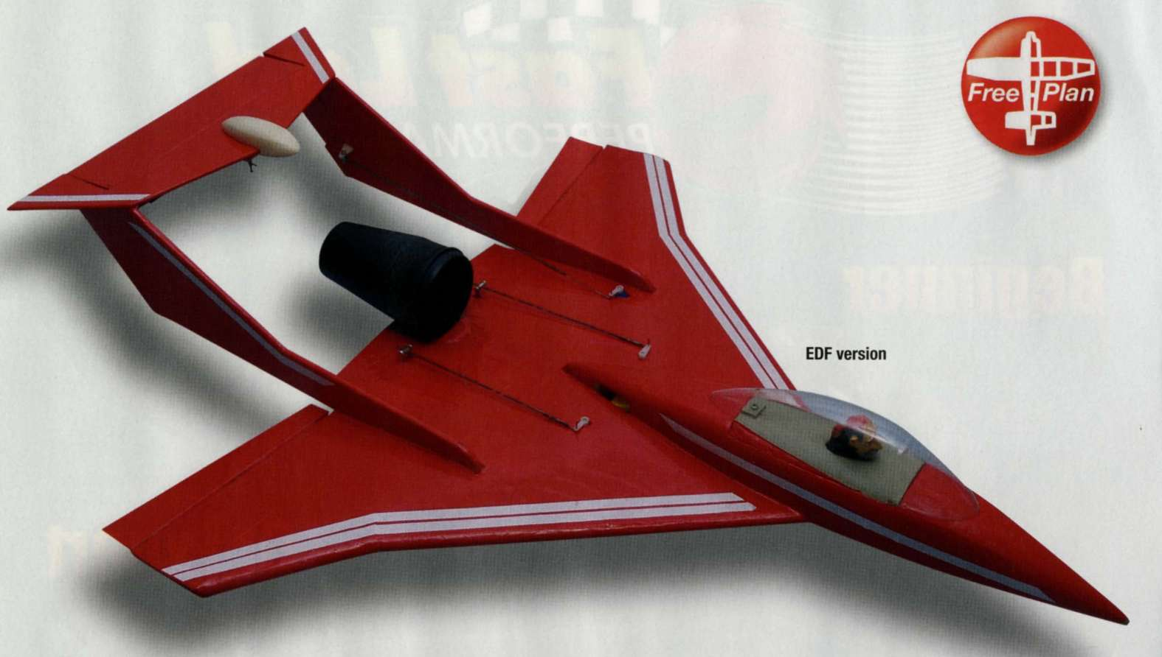

Basic wing and fuselage construction is of 6 mm Depron with 1/4" sheet balsa main spar for the wing. One source of 6 mm Depron is Flitehook (see Contacts) but their standard sheets are too small for this wing and you will have to contact them regarding larger sheet sizes. Note: as Depron is very easily dented, marred and damaged, it is advisable to cover the wing and fuselage in 0.6 oz glass-cloth and Poly-C. This product is a varnish like liquid, water-based so the clean-up is water, is very easy to apply and there are no toxic fumes to worry about. The

Mike White's 762 mm span twin-boom delta for 300 watt pusher motors or 68 mm EDFs and 3-function R/C

booms are 1/16" (1.5 mm) sheet balsa sides over a 1/4" x 1/8" (6 mm x 3 mm) light framework and given a coat of Poly-C varnish only, to fill the grain. If you decide to use this finishing method I would advise that all the components are finished and covered before final assembly. A light spray paint would also take well to the Poly-C. My models are covered in Solarfilm.

CHOICE OF POWERTRAIN

Power is from a ducted fan with a fan diameter of 68 mm turned by a 40 Amp, 2570 rpm/V, 580 watt outrunner motor fed by a 4S 3000 mAh LiPo battery. The finished weight of the plane, ready to fly, is 40 oz, which gives a power-to-weight ratio of 230 watts per lb of model. I inherited the EDF unit from a friend but it came with no manufacturer's name or address, only the specs. I can only therefore, recommend suitable EDF units and all these have better specifications. At the time of writing all are obtainable from BRC Hobbies (see Contacts) and are as follows:

1. Het 6409 70 mm fan with а НЕТ Typhoon 2 W 20 motor. Requires a 4S LiPo for top performance but will perform well on 3S
2. WeMoTec 480 Minifan with the above motor
3. E-flite Delta-V 15 fan with the E-flite BL15 motor and, for top performance needs a 4S LiPo battery
4. Lander EDF-68-1A includes the motor and only needs a 3S LiPo for top performance
5. Lander EDF-68-HP for 4S LiPos would be my ultimate choice for screaming performance

Any of these combos will produce in excess of 350 watts/ pound of model on 4S batteries and will be much faster than

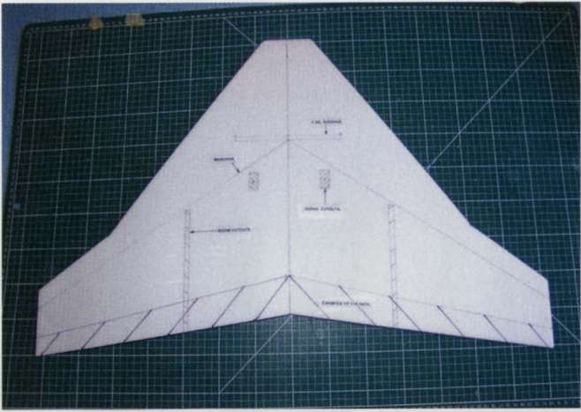

Wing surface; hatched areas to be chamfered to 1/16" at trailing edge; spar, boom and servo positions marked

my model. This power will take the model to speeds of Warp 4 or higher and will guarantee to put an everlasting smile on your face. You may be able to get away with a 3S battery on some items but check with BRC first. Due to the high performance using any of the EDFs mentioned, the Tuboomer is for the experienced flyer only but will make an excellent first EDF model due to the ease of mounting the unit. This is mounted on a 1/8" (3 mm) ply base but I will have to leave you with the fine details of your specific mounting, as I do not know how your particular motor is attached.

As an alternative source of power I have used a BRC Wasp 2835/2700 rpm/V 300 watt inrunner and a BRC Wasp 2814/5T/1660 rpm/V 350 watt outrunner with pusher props, both giving an exciting performance on 3S, 2200 to 3000 mAh LiPo batteries. With an 8" x 6" prop the model is very fast, aerobatic and hand launches well and with ease.

Now a word or two regarding batteries for the EDF version: cheap items supplied by unfamiliar manufacturers are usually okay for the lower current drain of an outrunner motor driving a pusher prop, but for the high amps (current drain) of the EDF unit their performance may disappoint. I really would advise 3000 mAh high quality batteries of a known make and of a rating of at least 25C.

FUSELAGE

The fuselage is a simple box construction from Depron with some balsa strip at the corners and 1/32" (1 mm) ply doublers at the sides with a balsa nose block. The corners are attacked gently with sandpaper to give a fairly well rounded shape.

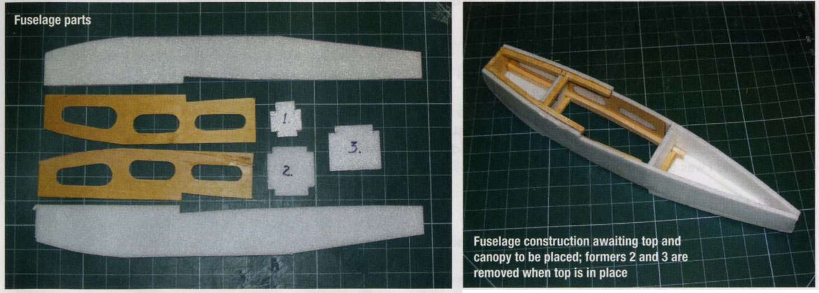

Lay the fuselage over the wing with its centre line matching

the wing centre line. Mark the wing where the fuselage touches and cut this away so that the fuselage sits accurately in the hole. You .will also have to remove parts of the fuselage sides to enable it to fit over the spars. Glue in place with epoxy. To finish off the fuselage a very nice clear canopy is available from Traplet Plans Service (order code CA3581CY) and this is mounted atop Depron and acts as the flight battery access hatch. I secured mine with a 1/32" (1 mm) ply tongue at the front and a magnet at the rear. The battery tray is a length of 1/8" (3 mm) Lite-Ply with a length of Velcro glued to it. The battery also has a piece of Velcro glued to it to match position with that on the tray. To add a belt and braces touch, another Velcro strap goes around and under the tray and ends up on the battery top mating with yet another Velcro piece glued to it. Very secure.

ASSEMBLY PREAMBLE

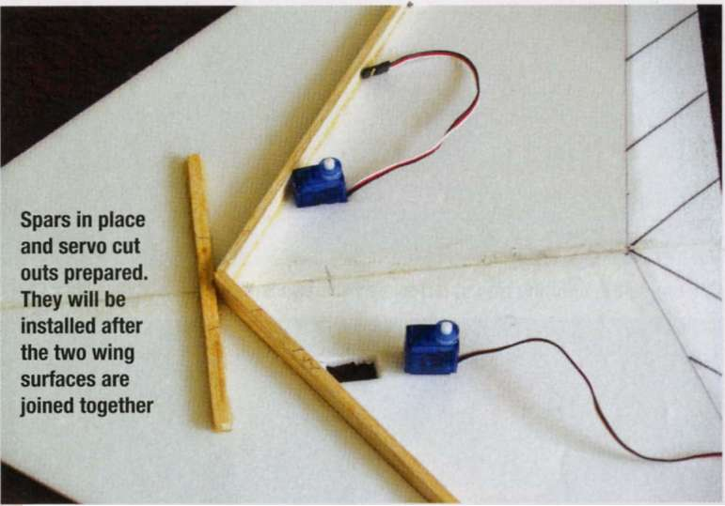

FREE PLAN

To ensure correct alignment of the booms and tailplane it is advisable to do a dry run before applying glue. Assembly of the booms and tailplane will take up quite a lot of space so prepare your work area accordingly. Using the top wing skin's longitudinal join line, or drawn centre line, as a datum, mark the positions of the booms on the top skins, cut slots as indicated and endeavour to make the booms a smooth sliding fit in them. Do the same on the bottom skins. Slide in one boom ensuring that the bottom extensions are sitting flat on the worktop and check that it sits truly vertical. Make any adjustments to ensure this by opening up the slots in the bottom skin. Eventually, when you come to glue in the booms, any gaps in the bottom skin can be filled with soft balsa or slivers of Depron.

60 MAY 2012 I [**WWW.RCMODELWORLD.COM**](http://WWW.RCMODELWORLD.COM)

[**WWW.RCMODELWORLD.COM**](http://WWW.RCMODELWORLD.COM) I MAY 2012 61

TUBOOMER

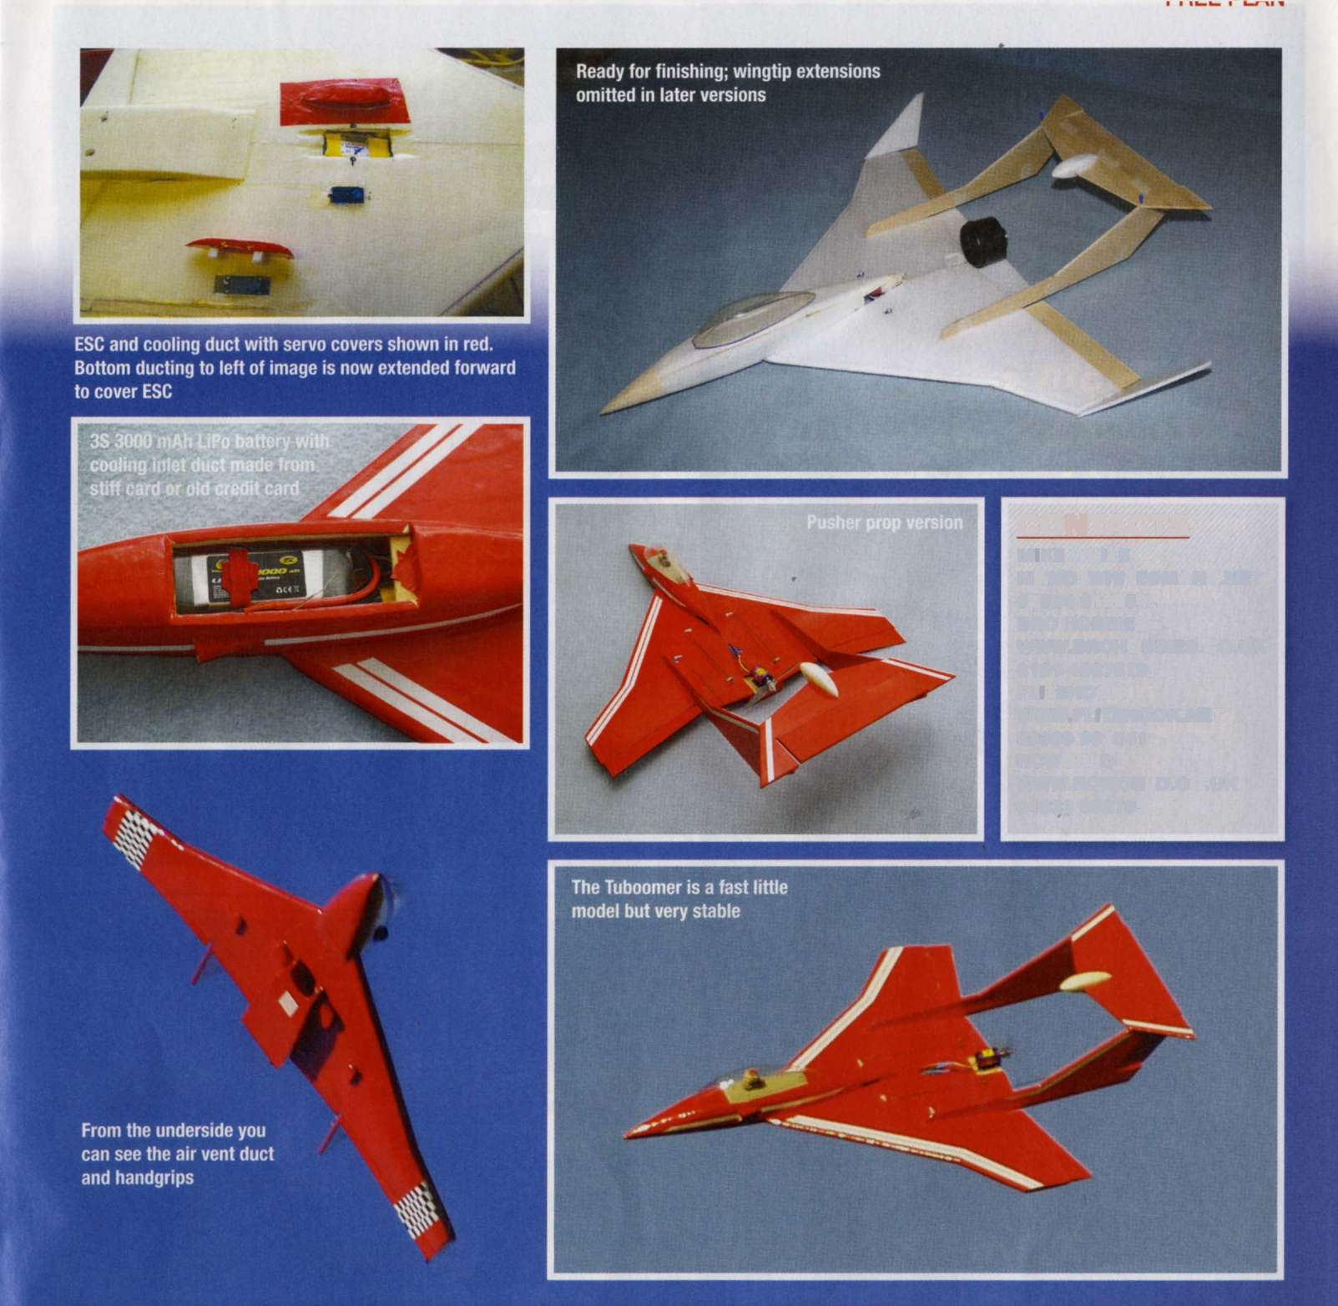

cdcc dl дм

CONTACTS

mike white

[mandjwhite@manx.net](mailto:MANDJWHITE@MANX.NET) 01624 813654 brc hobbies

[www.brchobbies.co.uk](http://www.brchobbies.co.uk)

0191 4887879 flitehook [www.flitehook.net](http://WWW.FLITEHOOK.NET) 02380 861541 rcworld

[www.rcworld.co.uk](http://www.rcworld.co.uk)

01633 682795

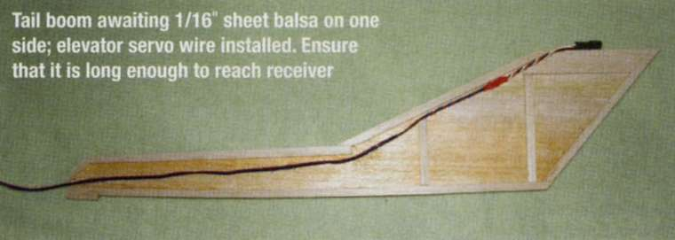

EDF unit in place; wing secured to building board with top and bottom wing surface join lines parallel with board; set-square ensures that EDF is set with zero up and down thrust

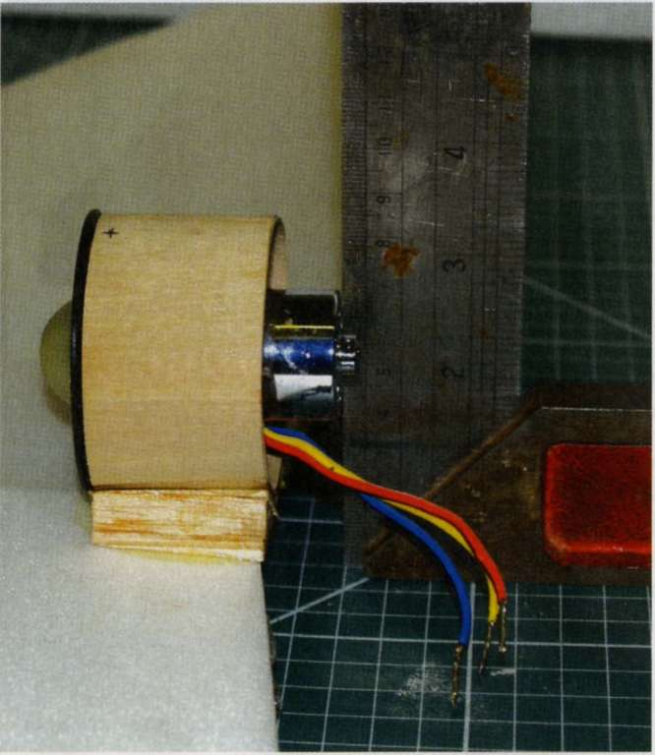

EDF unit with mounting ring at left made from two laminations of 1/64" ply

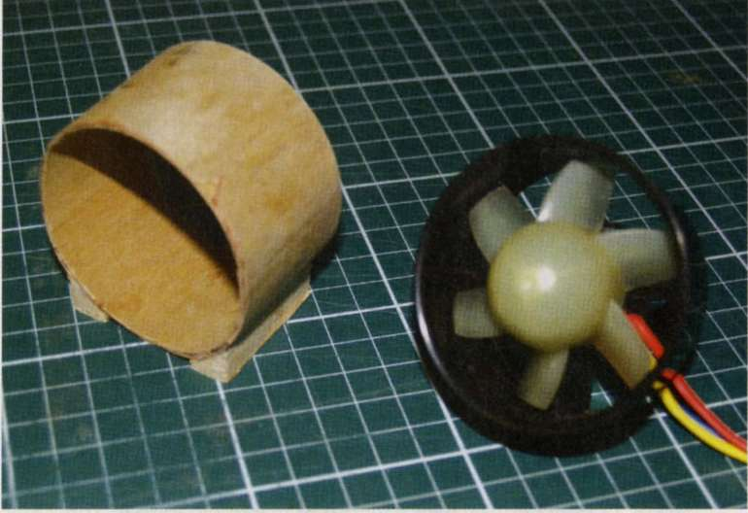

maximum. Cooling, with the fan motor out in the breeze as it is, should present no overheating problems but do ensure that the ESC is well cooled and that there are as few obstructions around it as possible. With the radio switched on and all transmitter trims set to zero set the aileron trim neutral using the aileron setting jig shown on the plan and set the elevator in line with the underside of the stabiliser. With the prop model set the ESC brake off to prevent prop breakages on landing.

FLYING

Prop version. For the first flight balance at the forward position and set the elevator trim about 2 mm up to ensure a good climb out at launch. It is advisable, on these hand launched models, to get a buddy to do the first few launches for you until you have the trim sorted out. Grip the model by the bottom duct, which will provide a good hold. Alternatively you could use a light bungee and to this end a hook is indicated on the plan.

The first two EDF flights were in calm weather and, luckily, over thick heather, when the launch was not strong enough and resulted in the nose burying itself, luckily without damage to the model. The third was a total success and, although the plane was not as fast as I would have liked it was adequate and all the basic aerobatics were possible with very smooth control responses. On landing, with the power off, there is plenty of control authority on elevator and aileron.

THE END BIT!

Should you have any problems with the build or flying of the Tuboomer or comments, pro or con, please contact me (see Contacts) by phone before 2100 hrs or by email. Any good images of your model over 1 MB file size with a little information will be most appreciated as they could be used in this most graphic of model building magazines! RCMUlf

Repeat for the other boom. Check from above that each one is aligned with the other and from the side. Dismantle the parts and very carefully trim the boom slots on the top of the top wing skin to achieve a shallow 'V' so as to provide a good glue line.

BOOM ASSEMBLY AND TAILPLANE SETTING ANGLE

Using the top and bottom wing skin join glue lines (at the LE and ТЕ) as a reference line set each one 19/16" above the work surface. This measurement is taken at the LE directly in front of the boom where the top and bottom surfaces join and the other where the boom exits the wing. Secure the model so it cannot move and epoxy the booms, one at a time, using the 30-minute variety. Pin a length of straight balsa to the top of each fin, which is long enough to reach a little further than the wing LE. Trim the top of the fins, if necessary, so that the balsa strip is 1/16" higher at the fin ТЕ than it is at the wing LE. Using 30-minute epoxy glue the tailplane atop the fins and, by 'eye-balling' from behind and above, align them with the aileron hinge line, adjusting as you go. Finally, insert two wood cocktail sticks through the tailplane and into the fin on each side and, again, epoxy in place.

I'm sorry that the preceding operation sounds so long- winded but, in truth, it takes a lot longer to explain than it does to accomplish and once you have done a dry run the procedure will become obvious. After all is set up and the glue is in place one should return to the scene a few times just to make sure that nothing has slipped out of alignment. I set up my first Tuboomer in about 45 minutes, which included the gluing... and I was feeling my way around the problems!

SETTING UP

EDF and pusher prop motor. Fit ail the electric bits and pieces and set the balance at the forward point. Check also that at full power the motor load is within limits and that the battery discharge rate is about 75-80%, or less, of its

[**WWW.RCMODELWORLD.COM**](http://WWW.RCMODELWORLD.COM) I MAY 2012 63

62 MAY 2012 I I[**WWW.RCMODELWORLD.COM**](http://WWW.RCMODELWORLD.COM)

A

quiet summer's eve, when the winds are down and swallows are busily swooping above the weeds, eating those pesky mosquitoes. That's a great time for a relaxed flyer, such as the Perky. With two square feet of wing area to support under a pound of weight, she's a nimble floater. Throttle up and she'll climb almost vertically and loop for as long as you want to hold the stick back. Throttle back and she's a very placid and forgiving trundler.

A 450 brushless 80 watt outrunner, a 3S 1250 LiPo, APC 8" x 3.8" Slow-flyer prop and a Castle 18 Amp Thunderbird ESC provide the power package, whilst a Spektrum micro receiver and a pair of Hitec HS-55 micro-servos take care of the controls. Her bones are all balsa and Lite-Ply, with a dash of aircraft ply - no exotic materials! Her constant chord wings differ only in span, rib spacing and attachment methods. So, the ancient bugaboo of biplanes, i.e. cutting out lots of ribs, is about as simple as it can be.

Construction

Although the Perky could serve as a trainer for the novice flyer, she isn't for the novice builder. I expect that you would have some expertise in building before tackling even as simple a project as the Perky, so I'm not going to go through how to glue each stick in place. Besides, you may have a better way to do it - in which case, I want to know so I can swipe the idea for another project!

Tail Feathers

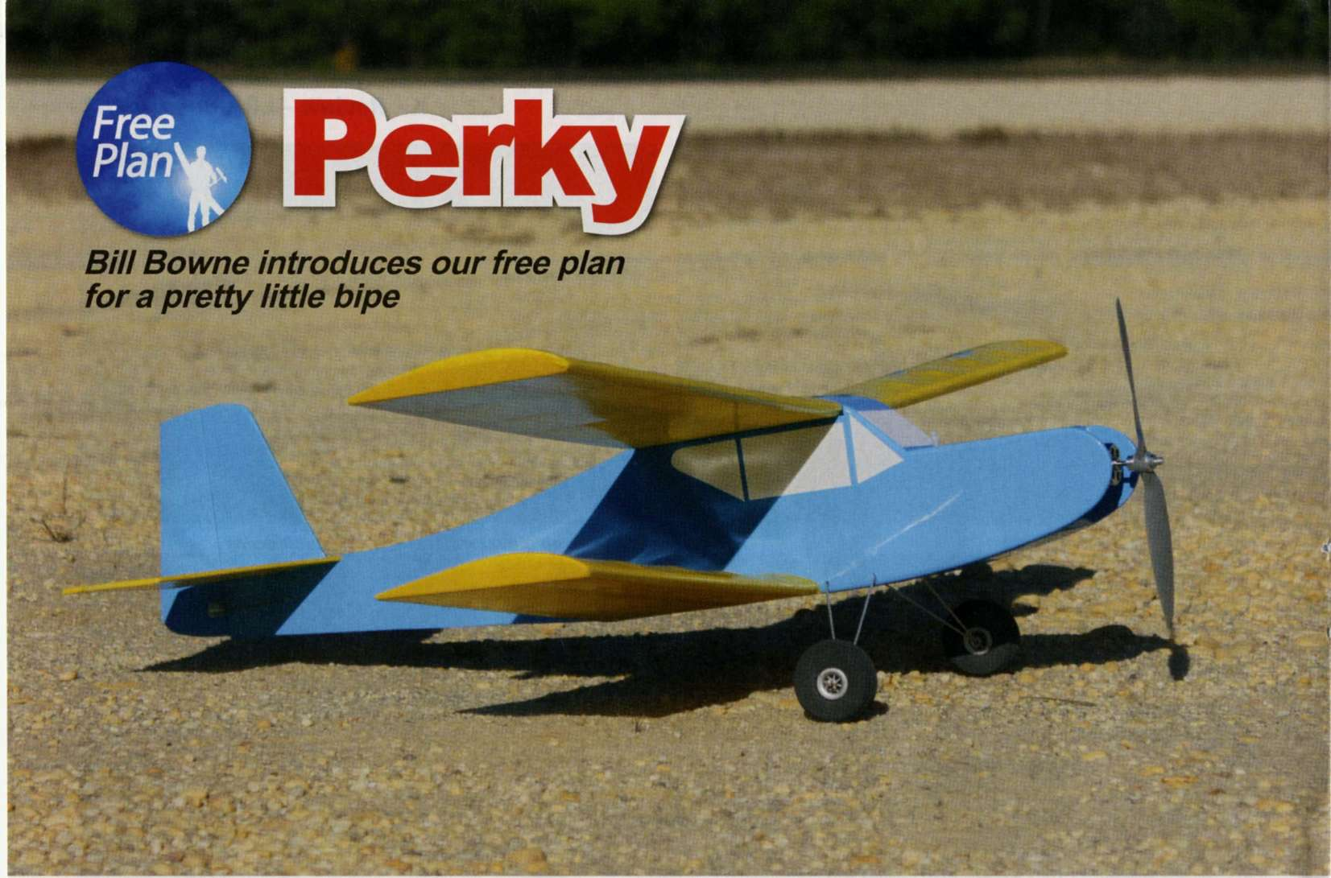

The tail parts are pretty straightforward. About the only quirk is that the rudderpost and stab ТЕ notch together, and the vertical stab LE fits into a slot in the horizontal stab centre section. I didn't bother with tapering the elevators and rudder. The power package I used is more than enough to balance a little extra wood in the tail, plus the thicker tail surfaces are harder to warp.

Wings

Instead of using butt joints for the rib-TE joint, I slotted the 1/8" x 3/16" ТЕ stock for the ribs. I used a homemade tool, shown somewhere around here. The resulting joints are much stronger than butt joints!

I don't like building wings in separate panels, sanding the roots and gluing them back together. So, I make the dihedral joints by cracking (or just partially slitting) the LE, ТЕ and spars. Later, when the rest of the wings are dry and before removing them from the building board, I'll dribble thin CAonto the cracks to harden them.

Wanting to speed up the construction of Perky's two wings, I set up my building board with a panel large enough for the upper wing and blocked up another shorter panel for the centre section. I also made the board deep enough (chord-wise) to do two wing panels at the same time. I then built the bottom left and top right panels (plus their associated centre sections) at the same time, finishing four of the six wing panels at one shot. Why the bottom left and right? Umm, because I pinned the plans down that way and didn't realise it until one wing panel was well underway.

Before I pulled the panels off the boards, I added everything, including the shear webs, but NOT the top spars. Before we go on with the wing, let's talk about shear webs.

I prefer to use my shear webs to make T beams. Yes, it's easier and faster to glue them to the edges of the spars and make 'C' beams but I think the slightly lighter weight and greater strength are worth the effort. Also, I use vertical grain for the shear webs. I know some folks prefer to run the grain span-wise instead of vertically, but I do it my way because I've yet to have a wing done that way fold.

Once the shear webbing is glued in, a scrap of 1/8" x 1/4" wide hardwood, with sandpaper glued to the 1/4" side, makes a handy tool to even out the shear web tops. After the webbing is flush with the spar slots, glue the dihedral braces in place ALONGSIDE the

shear webbing and flush with the spar slots. Hold off on adding the top spars for now.

Remove the wings from the building board, swap sides (blocking up the completed panels) and build the opposite outer panels all the way to this point. Now, crack both top spars at BOTH dihedral joints and glue them into place, then harden the cracked areas with thin CA. Add the scrap fill to the top wing centre section and sand it flush with the ribs, then add the top centre section sheeting.

Sand the excess spars, LE and ТЕ flush with the tip rib, and glue on the triangle stock wingtips. Next, carve the tips to match the aerofoil and sand the wings to shape. Voila, two three-panel wings!

Fuselage

I like to prepare as much as I can ahead of time. So, I sewed the landing gear tubes to F3 and F4 and the tailskid to its plate using Kevlar fishing line; then I soaked the line with thin CA.

Pin the 1/32" forward fuselage sides, tail doublers, and facing strips to the plans. Note that the grain of the tail doublers is vertical. The facing strips keep the covering from sticking to the sides of the verticals, leaving you with smoother fuselage sides. You will have to remember to use scraps of 1/32" balsa to keep the 1/8" sq verticals and diagonals off the plans though!

When you join the fuselage sides, watch out for two issues. One, the landing gear tubes go on the FRONT of F3 and F4. The second is to make sure the wing bolt plate fits through F5. I didn't do the latter and had to hurriedly sand the slot whilst the aliphatic glue dripped all over the workbench. This is one reason I'm glad I don't use CAfor regular building.

Use a length of brass tubing on each side of the landing gear, both to hold the wires together when soldered and to act as axles. Whilst you're at it, solder a washer to the inboard end to keep the wheel

in place. After the wheels are in place, restrain them with more washers or wheel collars (or grind slots in the tube and use 'e' clips). When you're satisfied, remove the gear for now.

Place the bottom wing onto the building board, line up the fuselage on it and glue the fuz to the wing. Sand the lower rudderpost to a shallow 'V' shape to accommodate the tapering of the fuselage at the tail. Bond the vertical stab to the horizontal stab, making sure it's square. Now, glue the tail assembly to the fuselage, keeping the tail square with the bottom wing. At the same time you'll be gluing the fuselage sides together.

Mount the top wing, keeping it parallel to the bottom wing. Your objective is to have 0 degrees of incidence on both wings and on the stab. I recommend leaving the balsa 'windshield' off until after you've drilled through F3 and the wing for the wing hold-down dowel. As to the wing bolts, I used a pair of 8 x 32 nylon bolts to hold the rear of the wing down, tapping the wing bolt plate for them. You could use blind nuts and other bolts, if you choose. If you decide to use larger wing bolts (or a single bolt), I recommend gluing another sheet of ply to the wing bolt plate before you drill and tap, to give a longer 'bite' for the threads.

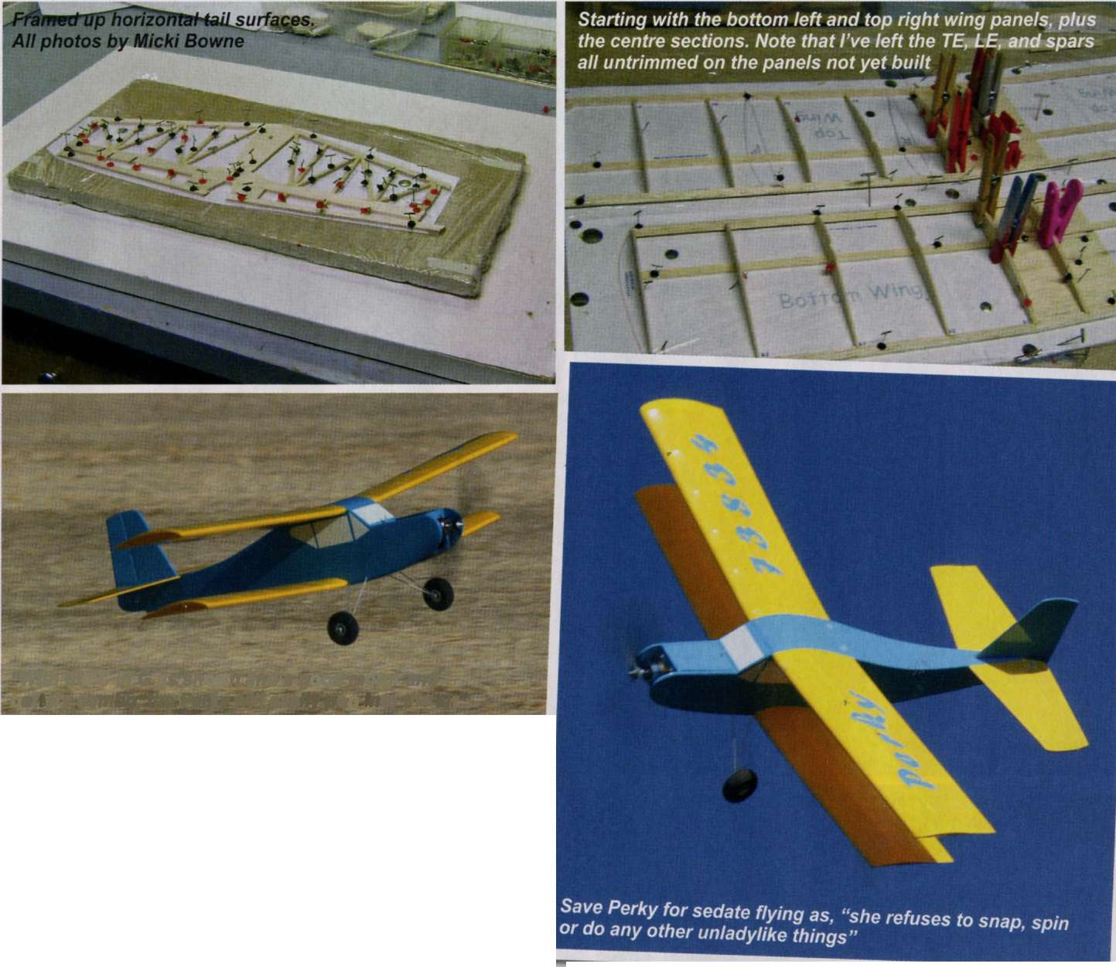

"With the С of G as shown and a good motor and battery combo, the Perky will easily pop into the air"

Tape the control surfaces in place, add the control horns and install the pushrod outers. Add the tailskid assembly and then sand the model.

Free Plan - Perky

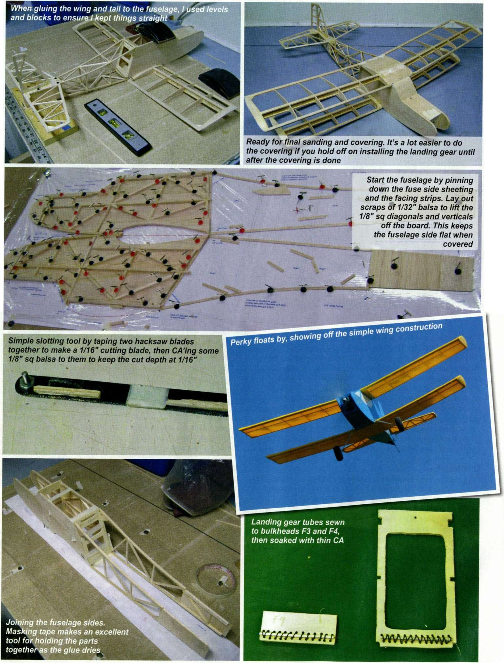

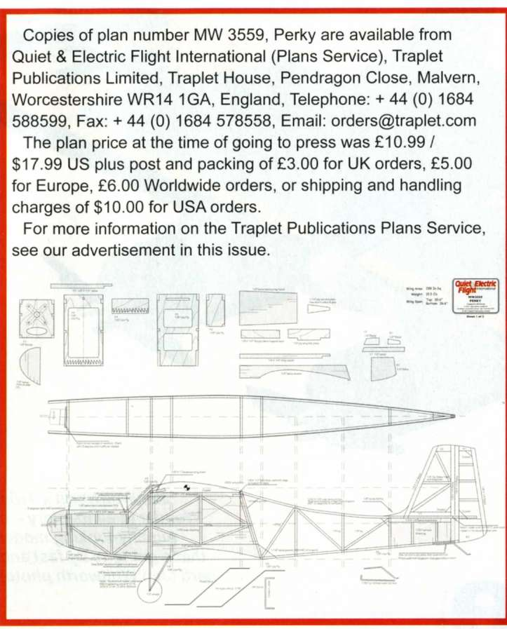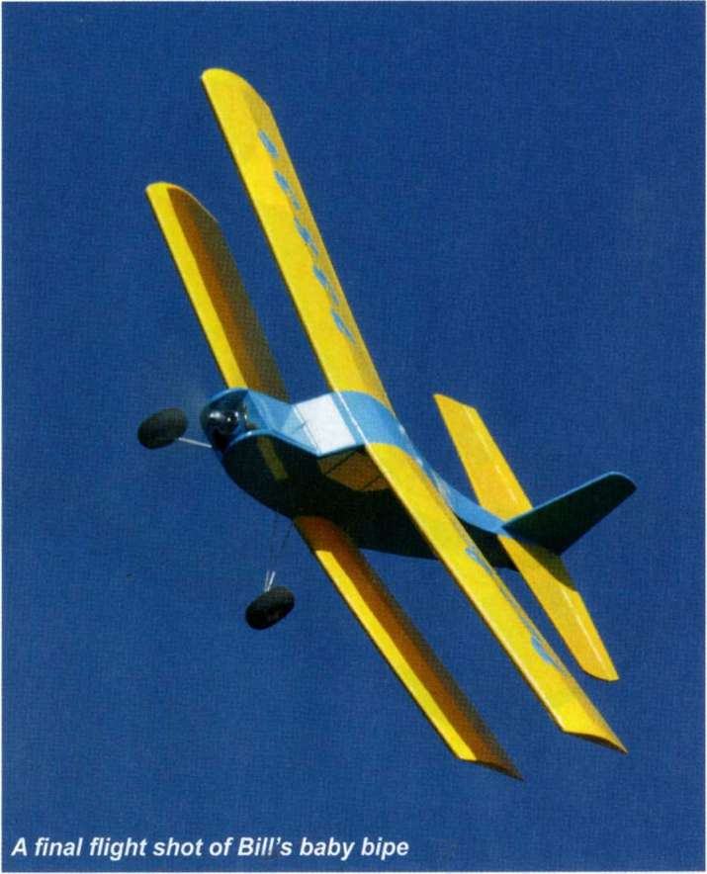

Covering

Cover with your favourite film, using the film to hinge the nose hatch. I used Doculam (document lamination film) on the wings and horizontal surfaces then painted them with Krylon aerosol paint. The fuselage and vertical surfaces are covered with light blue covering film, which I also used to make the AMA number and name. As long as I keep the temperature low, I can safely iron covering film over painted Doculam without melting the paint.

Why the mix of covering materials? It's because Doculam doesn't stretch after shrinking, so the washout I put in the wings WILL stay there. If you want to try Doculam, there are many different techniques and paints. I suggest a short search of the Internet to find one you prefer. Whatever you cover the wings with, twist the BOTTOM wing trailing edges up about 1/8" at each tip and use the covering material to hold the twist in. This is important! The twist guarantees that the top wing will stall first, followed by the bottom wing centre section. This is key to the Perky's stability and guarantees that the model won't fall off on a wing under most stall conditions.

One more point about covering: do remember to leave a section under the tail uncovered, for cooling air to exhaust.

Finishing Touches

Locate the holes for the landing gear tubes on one side, push thin wire through and open the holes on the other side. Clean the gear struts with acetone. Making sure you have the correct strut on each side, slide them into place and secure them with a little thin CA where the struts exit the fuselage.

Install the radio, motor and ESC. Use washers under the motor screws to get 3 degrees of right thrust, adding or removing washers as needed. I found that I didn't need any but your experience may be much different.

Balance the model as shown. I used a heavy motor so I wound up with the batteries sitting almost under the С of G. Set the control

throws at + 1/2" for the rudder and +1/4" for the elevator (to start), and you're done!

Flying Perky

With the С of G as shown and a good motor and battery combo, the Perky will easily pop into the air and climb almost vertically. She's quite willing to loop and she'll putter along low and slow, but she refuses to snap, spin or do any other unladylike things. She definitely won't stay on her back for very long; if you don't keep some positive 'G' on her when rolling, she gets very unhappy and gyrates around to right-side-up almost instantaneously. So, barrel rolls are fine, but axial rolls just won't happen.

Have fun with your Perky! Q&EFI

Specification,

SPECIFICATION

Wingspan: 30.6" top, 26.6" bottom (777 and 676 mm)

Area: 288 sq in (1858 sq cm)

Wing Loading: 7.75 oz/sq ft

Length: 27.3" (693 mm) /'

Weight: 15.5 oz (439 g)

Motor: 450 brushless 80 watt outrunner

Prop: 8" x 3.8"

ESC: Castle 18 A ESC

LiPo: 3S-1250

Radio: 3-channel

CONTROL THROWS

Elevator: 1/4" each way Rudder: 1/2" each way V J

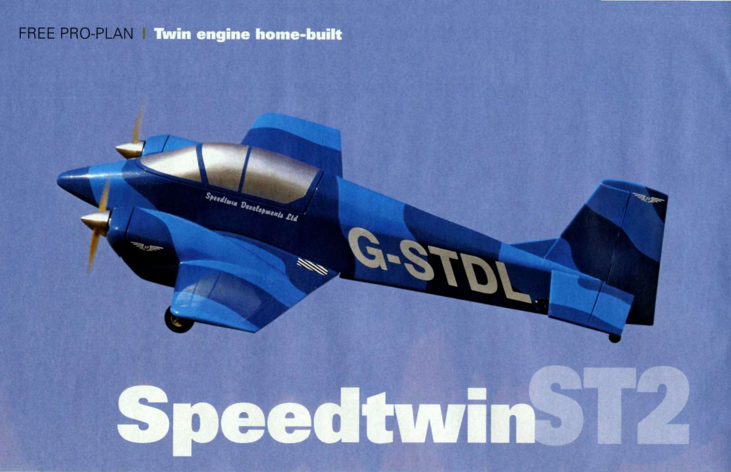

A blue plane in a blue sky! Surprisingly, there's no problem with orientation.

The fronts of the cowls are located by short dowels, then secured with double-sided sticky pads.

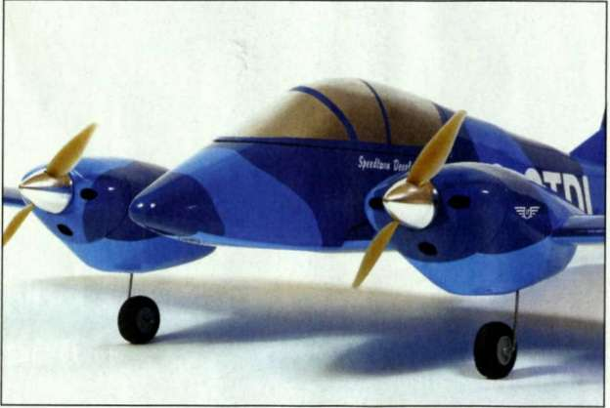

TIM HOOPER MODELS A RARE BEAST-A BRITISH TWIN-ENGINE AIRCRAFT DESIGNED FOR THE HOME BUILDER

I

t's fair to say that the late Peter Phillips knew a thing or two about aeroplanes. During his time in the RAF he flew Meteors and Vampires, while in civilian life, he flew for both Beagle Aircraft and Britten Norman. In the '60s he was also the UK sales manager for the Victa Airtourer, an able and aerobatic Australian-built single that deserved a better fate than to be smothered by cheaper and more pedestrian American trainers. Something of the Victa's zest did live on, though, in Phillips' 1981 design for the Speedtwin ST1 - a lively aluminium-skinned twin that mated the Airtourer's wings with a slender, tandem fuselage seating two, and which, for all its sophistication, was aimed at the home-builder.

Although Peter passed on in the '90s and the original Speedtwin, G-GPST, has apparently been sold abroad, the whole project has been lent new vigour by Malcolm Ducker, who is a former Hawker Hunter and commercial jet pilot, and now the MD of Speedtwin Developments. In 2007 a second demonstrator, the ST2, was built, in which the original 100hp Continental 0-200 engines were replaced with 200hp units, giving even livelier performance. When my eye was caught by photos on the RCM&E forum of G-STDL's blue pseudo-camouflage scheme, the ST2 went straight onto my to-do list, and I promptly contacted Malcolm to ask his permission to draw up plans for this 1:7 scale, electric-powered sport model.

MAKING THE WINGS

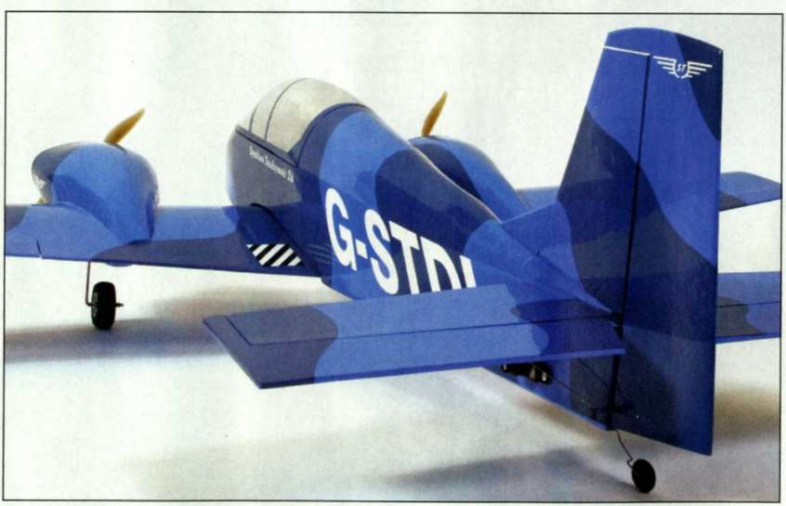

The wing starts life as a set of 1/16" sheet skins, which I made by edge-jointing together nine 22 x 4" sheets with aliphatic glue. Once dry, the two lower skins can be cut to size, taking their dimensions from the plan and noting that they only extend forward as far as the rear of the leading edge. Mark the skins with the rib and spar locations before

offering up the two sheets to each other, root-to-root, to double-check that the main spar runs in a straight line from tip to tip. Sand the bottom surfaces of the skins smooth and pin them, sanded face down, to the building board.

Add the 3/16" square bottom main and rear spars, together with the 1/4" aileron leading edge; the leading edge itself can be cut oversize and pinned to the board directly in front of the skin.

Unfortunately, when it comes to the ribs, their unequal spacing means that it's not possible to make them using the sandwich method; instead, you'll have to cut them all individually. While you're doing this, you'll notice that the ribs are flattened on their lower edges where they fit between the main spar and trailing edge, which makes it easy to glue ribs R3 - R10 to the skin. The root ribs, R1 and R2, will be fitted later, but in the meantime add a little packing to the top of the rear spar to bring it level with the ribs, and then fit the upper spar, followed by the vertical sheer webs between R3 and R7. When these have dried, you can unpin the panels from the board and, using cyano, glue the skin in front of the main spar to the ribs.

Cut out the aperture for the aileron servo and remove the front sheeting between R5 and R6. Then, with the panel pinned back onto the board, cut out the 2mm liteply motor mounts. These are glued to the inner sides of R5 and R6, using a jig to raise their front edges off the board by 23mm. This alignment gives the engines zero down thrust; the 2° of down thrust shown on the plan is added later using shims fitted behind the upper mounting lugs.

The 1/8" ply firewalls come next, together with bracing fillets of 1/4" balsa strip, this before adding the 1/16" cross grain sheeting to the top and bottom of the motor mounts. Finally, the area aft of the leading edge, from which we earlier cut away the lower sheeting, is now in-filled with 1/8" ply to form the undercarriage mounting plates.

DIHEDRAL AND WASHOUT

The two wing panels are joined using 1/16" ply dihedral braces and some hard balsa reinforcement at the rear spar. With one panel flat on the board and the correct dihedral set, the tip of the other panel should be raised by 90mm. Add R1 and R2 fore and aft of the spar, and sand all the ribs level with the spars before adding reinforcement to the leading

edge for the front wing dowel, and laying in the motor wires and servo lead pull-threads.

words » Tim Hooper I photos » Tim Hooper / Annette Douglas / Bob Kemp

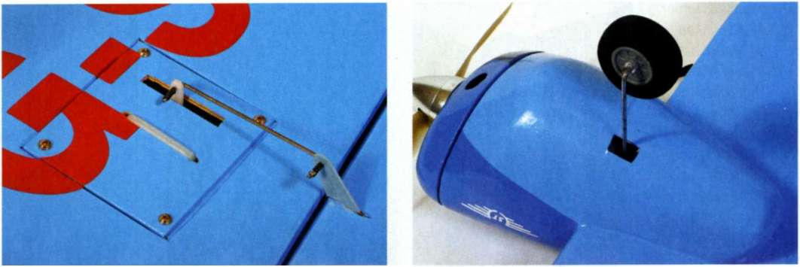

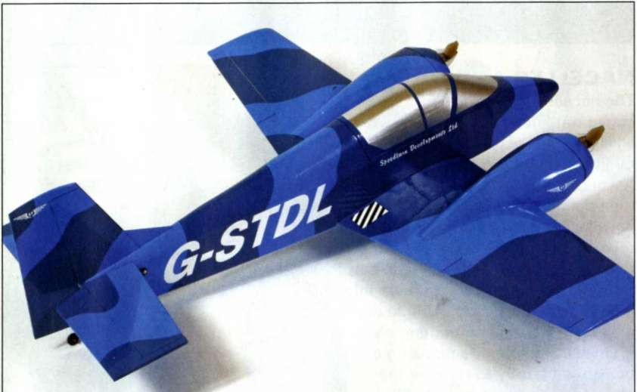

TOP LEFT: Aileron servos are held in place with double-sided tape and a cable tie. Note the simple pushrod and 1/32 ply control horn; more than ample for a model of this size.

TOP RIGHT: A section of the lower nacelle is

temporarily removed to allow the undercarriage to be fitted. Strips of film hide the surgery.

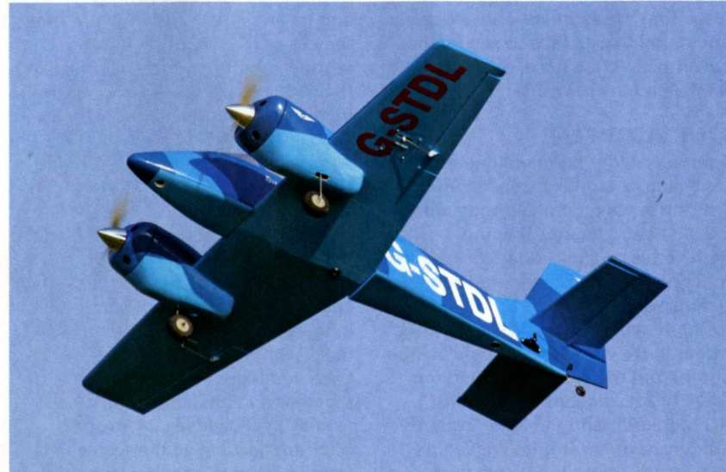

Although the 7x4" props look tiny in comparison to those broad shouldered nacelles, they're an ideal match for the powertrain.

The wings' 3mm of washout is easily built in by tack-gluing a long balsa wedge to the underside of the trailing edges so that when each panel is pinned back to the board in turn, it takes up a slight twist giving the required washout. The upper skin - in which you'll need to make holes for the motor and servo cables, as well as a cut-out to fit around the motor mounts - is then cut to fit, glued into place, and weighed down to ensure that it stays firmly in contact with the wing structure while it dries. Once dry, add the tip blocks and sand them to shape, after which the motors can be trial-fitted to their firewalls, noting that they're designed to be offset so that they can be shimmed on one side to yield 2° of side thrust, which will help to counter the yaw created by two props turning in the same direction. Mind you, if you're able to fit your twin with counter-rotating propellers, you can dispense with this side thrust.

NACELLES AND U/C

The nacelles are quite time- consuming items to build because of all their planked construction. Start by fitting the upper balsa outer formers to the motor mounts and then delineate the outlines of the nacelles by gluing a thin strip to the top of the wing. It's then a matter of adding 1/4" wide strips of 1/16" balsa a couple at a time, pinning them into place and setting them aside to dry while you work on something else.

Once complete, the planking can be sanded gently to remove the obvious high spots prior to filling. Don't go berserk with the sanding block, though, there's not a lot of balsa there to begin with!

Make up the piano wire undercarriage assemblies and the brass P-clips that will secure them to their ply mounts, and then offer up the gear to the wing. When done you can add the nacelle's lower, outer formers to the motor mounts and continue the planking, using pieces of balsa block where necessary to cope with the areas of extreme curvature.

Refit the motors and the 45mm diameter spinners, and make up the cowl fronts from block balsa, not forgetting the air inlets. I used dowels and double-sided tape to secure the cowl fronts to the nacelles after the model had been covered.

TAIL AND FUZ

The fin / rudder and tailplane are both simple to make, consisting of 1/8" strip wood cores skinned with 1/32" sheet; the only shaping involved is on the rudder core, which must be sanded to a tapered section before adding the skin.

FREE PRO-PLAN I Twin engine home-built

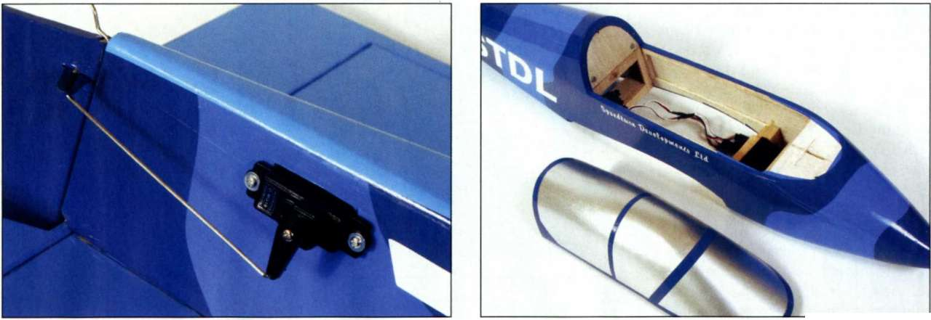

The exposed rudder servo is linked to the rudder in the same way as the ailerons; just a simple bent pushrod. A short length of servo wire outer insulation ICA'd in place) serves as a retainer at each end.

The canopy has a hook beneath its front end that locates around a dowel in the top of the nose block. Meanwhile, a dowel and magnets hold it in place at the rear. Simple and secure.

Ready to go! The three shades of Solarfilm appropriately echo the full-size colour scheme, whilst the italicised registration accents the lines of the model.

The fuselage, meanwhile, involves rather more work which begins with cutting out the sides from medium 3/32" sheet, then adding the 1/8" wing doubler and the 3/16" square longerons and uprights. Make up F1 to F4 from 3mm liteply and, with one of the sides pinned down, glue F2 and F4 into place, making sure that they're perpendicular; glue the second side to the formers, checking that all's square. When dry, pin the inverted fuselage over a centreline and pull the tail ends together. F3 and the wing bolt plate are then fitted, followed by the 3/16" square rear cross braces.

Bringing the front of the fuselage in to meet F1 means introducing a marked curve to the sides. To do this, I partially cut through the inner longerons, and sprayed the outside faces with water, softening them so that I could gently ease the sides together and glue them into place.

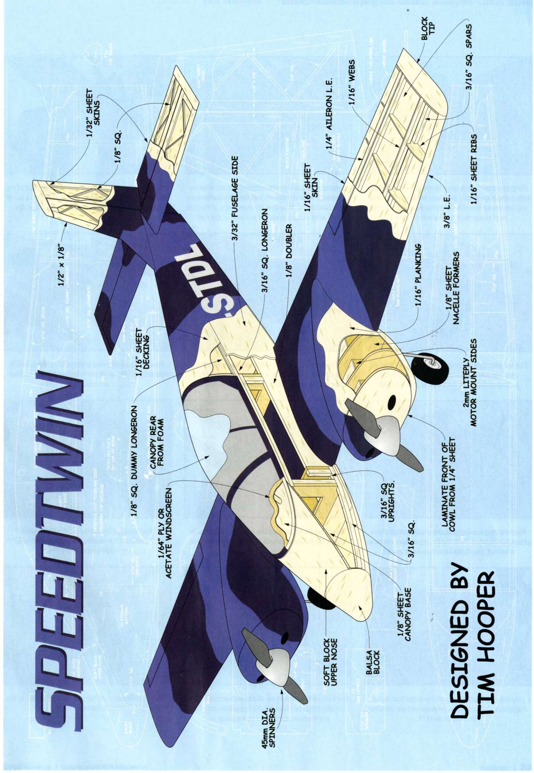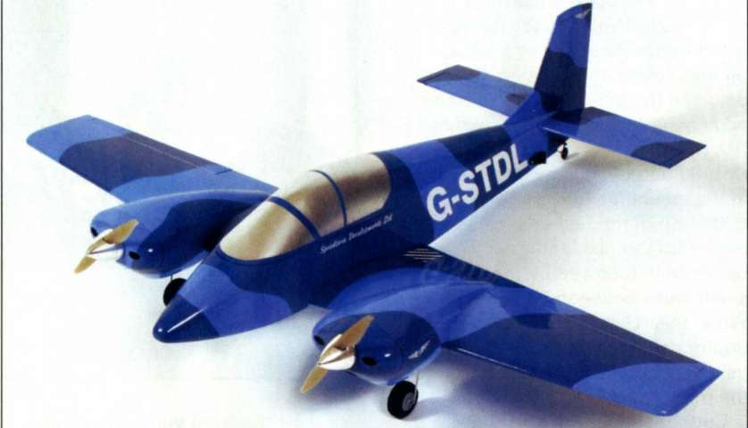

edge and fit the wing dowel. To ensure accurate alignment, I started off by fitting a small 1/8" dowel to hold the front edge of the wing central while I adjusted the trailing edge to give equal measurements from the sternpost to each wing tip. Then, with the wing pinned to stop it moving, I drilled a hole immediately ahead of the rear spar and straight through the mount plate within the fuselage, using a drill suitable for the 5mm wing bolt and blind nut. The front dowel hole was later reamed out and the dowel replaced with a 3mm carbon rod.

Next, with the fuselage right side up, add the dummy longerons along the inner rear edge of the sides, followed by the upper rear formers (F4a to F7a), and the 3/16" square

With the fuselage still inverted, offer up the wing so that you can drill through F2 and the wing leading

FREE PRO-PLAN I Twin engine home-built

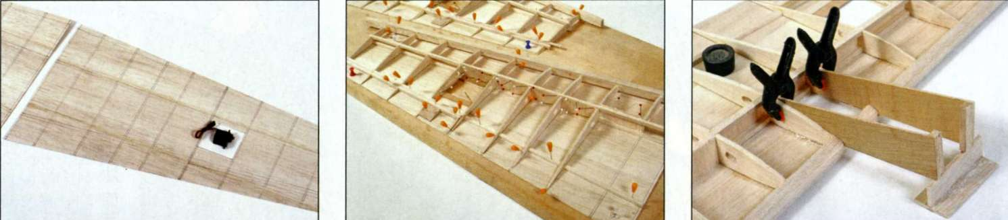

words » Tim Hooper I photos » Tim Hooper / Annette Douglas / Bob Kemp

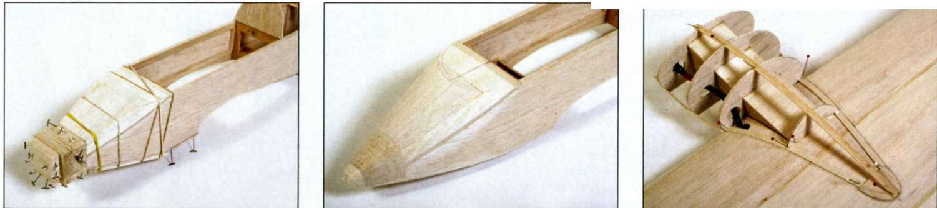

|  |  |  |
| --- | --- | --- |
| Wing construction starts with the lower wing skins which are edge-joined and then marked with the rib and spar positions. This is also a handy time to cut out the aperture for the aileron servo. | Spars and ribs are built directly on the lower skins. The root ribs aren't added until the dihedral braces have been fitted. Note that the front edge of the skin will need raising to meet the fronts of the ribs. | With the wing held flat on the board, the front of the motor mounts are jigged up by 23mm (using a scrap of balsa), and glued in place alongside the ribs. |

|  |  |  |
| --- | --- | --- |
| As you can see, the nose blocks are added as random lumps of balsa... | ...Prior to sanding them to profile. Keep the upper surface flat to form the base of the windscreen. | It's probably a good idea to spread the task of planking over a day or two, whilst carrying on with other parts of the ST2 in the meantime. |

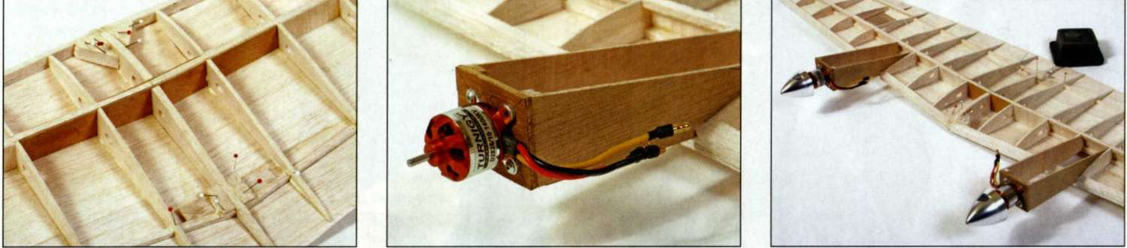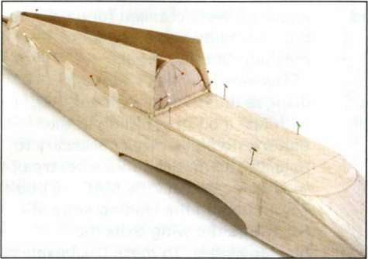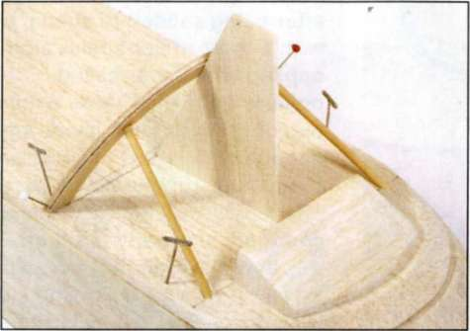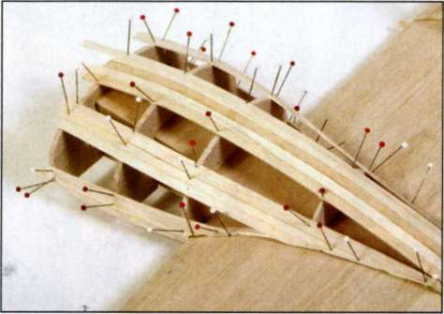

|  |  |  |
| --- | --- | --- |
| The wings are joined using 1/16 ply braces and the root ribs added afterwards. Additional balsa accommodates the front dowel and rear bolt. | These inoffensive-looking outrunners actually bestow the ST2 with a very lively performance. 1 used self-tappers to secure them to their firewalls. | Those little motors look dwarfed by their spinners, don'tthey? These 45mm items are nicely polished and balanced. |

|  |  |  |
| --- | --- | --- |
| With the base of the canopy pinned in place (onto a layer of protective Sellotapel, the rear turtle decking can be fitted, lower edges first. | Originally 1 was hoping to fit a clear canopy, so made this windscreen frame. No matter, for in the end it served as a former for the final, thin ply 'screen'. | Don't avoid this job. Trust me, it's not as bad as it looks and will be over before you realise! |

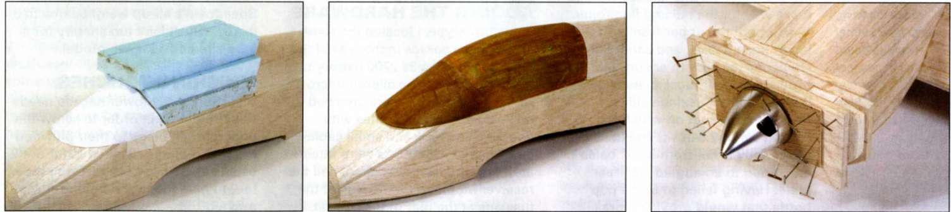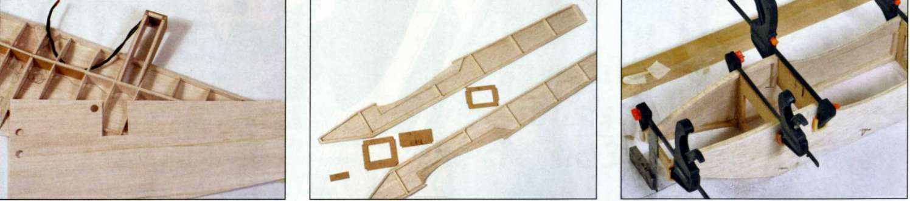

|  |  |  |
| --- | --- | --- |
| Here the motor wires and servo pull-threads have been laid in place. With the t.e. jigged up to induce washout, the upper skins can be attached. | The basic kit of parts for the fuselage. 1 used 3mm liteply for the formers and 3/32 balsa for the sides. | The fuselage is built inverted over a drawn centreline, then gently clamped together until everything is dry. |

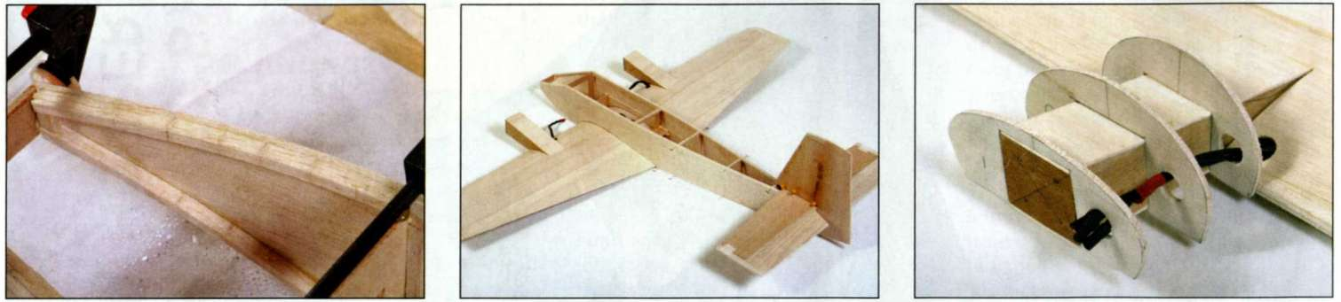

|  |  |  |
| --- | --- | --- |
| 1 found it helpful to dampen the balsa and make multiple cuts through the longerons to aid bending the front to meet F1. | The basic airframe looks a shade on the boxy side at this stage but fear not, it'll transform into a curvaceous work of art as we progress. | These 1/8 formers will form the sub-structure of the nacelle's planking. |

|  |  |  |
| --- | --- | --- |
| 1 cut the rear part of the canopy from chunks of blue foam, secured with aliphatic glue, then hacked into shape with a bread knife. | Sanded smooth and covered with a layer of glass cloth and a couple of coats of water-based polyurethane lacquer. | With the nacelle planking complete, the front portions can be laminated from scraps of balsa sheet and faced with liteply. |

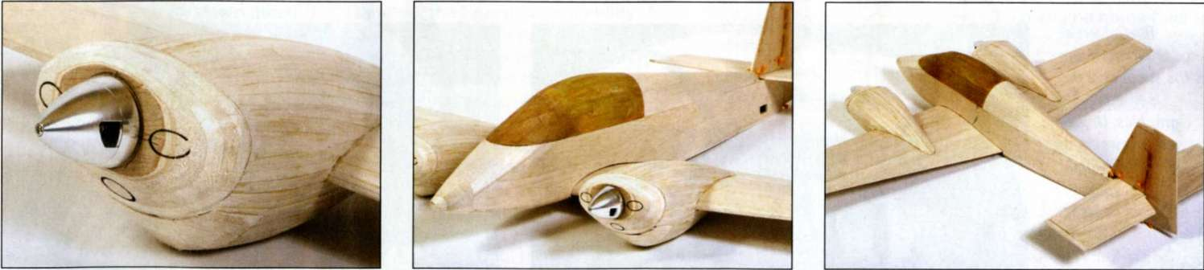

|  |  |  |
| --- | --- | --- |
| All sanded down and with the inlet holes marked out. 1 used a sharpened length of metal tube to form the initial holes. | Just about ready to be swathed in Solarfilm. The hole in the rear fuselage will receive the rudder servo. | Should you feel so inclined, blue foam would make a suitable alternative to all that nacelle planking. |

FREE PRO PLAN I Twin engine home-built

words » Tim Hooper I photos » Tim Hooper / Annette Douglas / Bob Kemp

It almost cries out spine. Note, incidentally, that F4a is

for a set of slanted rearwards. non-scale retracts, From here, you can either plank the doesn't it? rear deck with 1/16 x 1/4" strips, or go for broke and do it all with two pieces of 1/16" sheet. If you opt for the sheets, cut them oversize and glue their bottom edges to the top of the sides, dampen them with water, and then gently bend them to shape over the upper formers so that they meet along the spine, where you can glue and tape them into place while they dry.

Twin ESCs live on top of the wing, with their battery leads soldered together to connect to the single battery pack. The other leads head towards the Rx via a Y-lead, as do the aileron leads.

Tim Calvert at mode/markings, com is the supplier of the self-adhesive graphics. Unless you fancy cutting those little winged emblems yourself, of course...

No clever painting techniques required here, just a steady hand with the iron!

The tail fairings are built up around small offcuts of balsa which are tacked into position in the stead of the tail surfaces; when the fairings

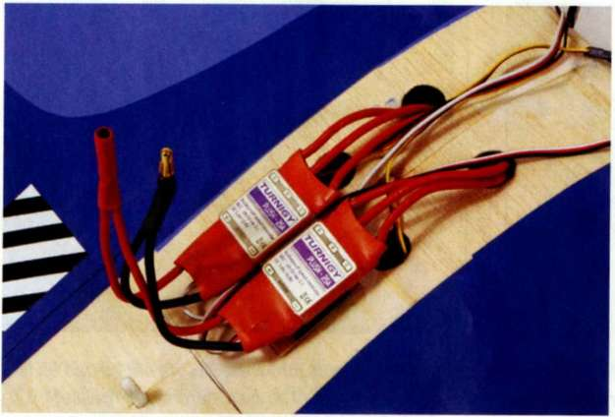

are dry, these offcuts are cut away to make way for the tail and fin proper.

Add both the upper front and lower nose blocks, and sand them to shape, taking care to ensure that the top of the upper block blends in with the tops of the fuselage sides, forming a flat seat on which the cockpit canopy can sit. The base of the canopy is cut from 3/16" balsa and glued to an angled 1/8" rear plate. Having failed to find a pop bottle that would provide a pre­formed canopy, I fabricated a windscreen frame from 2mm liteply and cut a front screen from 1/64" ply. The larger, rear part of the canopy was then shaped from foam and, after being sanded to shape, treated with a layer of light glass cloth, applied with water-based polyurethane glue. After a coat or two of primer / filler, it was smooth enough for a squirt of silver aerosol to give the impression of glazing. There may well be a suitable, commercial canopy out there, but this approach, on the prototype at least, kept things quick and simple.

To attach the canopy I used a dowel and magnets on its rear face, and a carbon-fibre or ply 'hook' that locates around a length of dowelling set into the top of the nose block.

ADDING THE HARDWARE

In the prototype, I located the rudder and elevator servos in the rear of the fuselage, and the 3s 2700 battery on a tray in the nose. The aileron micro servos, meanwhile, were attached to the insides of their hatches with double-sided tape and small cable- ties. The twin 25A ESCs were fitted atop the wing centre-section, and the receiver mounted on the side of the fuselage at the rear of the cockpit.

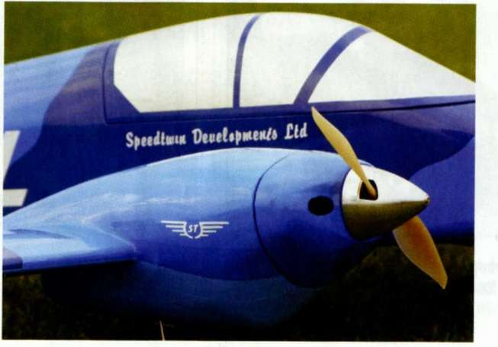

The control horns - which were attached with thick CA after the covering was finished - were cut from 1/32" ply and are identical. That said, the ailerons horns, when installed, were cranked forwards in a bid to provide some degree of mechanical differential.

The way in which I chose to dispose the hardware meant that, with just a bit of shuffling of the battery, no ballast was necessary to balance the model about a centre of gravity located at 28% MAC - a point 75mm behind the leading edge at R2, where the wing exits the fuselage sides. To make the business of balancing easier, I extended this С of G position out to the wing tips (40mm behind the leading edge at R10), and used fulcrum points to support the model there. The Speedtwin's all-up weight came to 3 lb 1oz, which isn't too shabby for a fully-sheeted 45"span model.

FINISHING TOUCHES

A section of the lower nacelle needs to be removed in order to screw the undercarriage legs to their plywood mounting plates, after which the balsa can be re-attached. Remember, too, to give the legs a little room to move by creating a clearance hole for them where they pass through the planking.

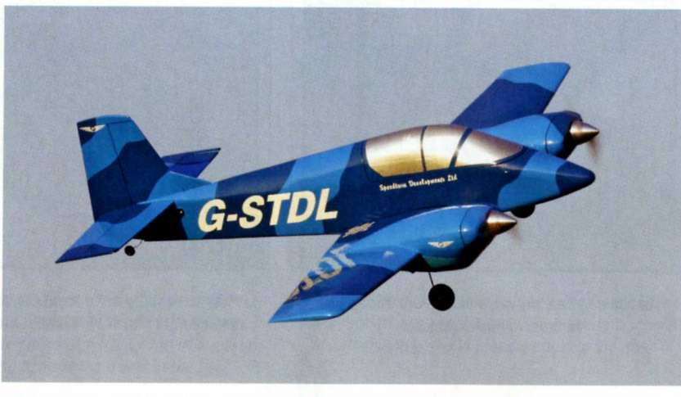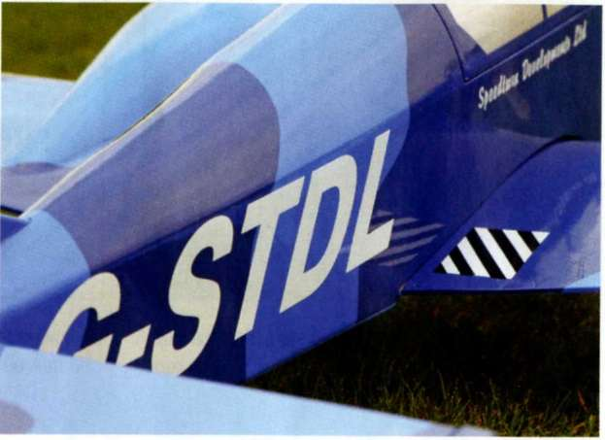

When it came to covering, I set out to emulate the three-tone blue camouflage scheme of the full-size aeroplane and, as luck would have it, the Solarfilm range includes some suitable shades, so there was no need to go looking for paint. Of course, just as the full-size ST2 is targeted at home-builders who'll choose their own colour schemes, you too could let your imagination run riot and devise a scheme of your own.

Once again, Tim Calvert at modelmarkings.com came up trumps with a set of superb vinyl graphics, including a workmanlike version of the Speedtwin Developments logo on the rudder and nacelles.

TWINS ARE MORE FUN!

One of the characteristics of this twin that becomes obvious the moment you begin to taxi is the lack of prop' wash over the rudder. This calls for some up elevator to be held in to give the tail wheel some authority so that the model can be steered. Once I had her pointed into the breeze, the throttle was advanced steadily and it became clear that the ST2 was eager to fly: she just picked up her skirt, lifted off the grass strip after around 10m, and fled for the horizon! In fact, she climbed away a little too keenly for my liking, to the point that I had to add a few clicks of down trim until I was able to take her back to the bench and build in the down thrust that's now detailed on the final plan.

That said, a quick check on the stall characteristics showed no tendency to drop a wing so, having completed the formalities, I was happy to open the taps and see what she'd do. No, the Speedtwin isn't exactly meteoric, but she's no slouch either. Powered by those Turnigy 2826/1 Os she goes just where she's pointed: inverted flight, big loops and smooth stall turns can all be flown easily, although I've yet to make her perform sustained knife-edge flight.

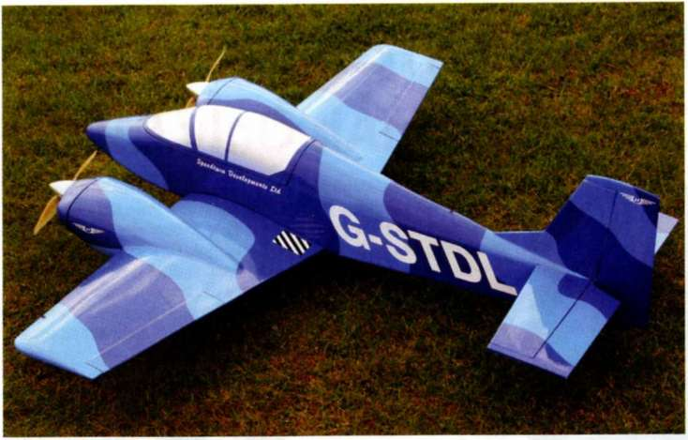

The big tail surfaces provide plenty of authority, though I've taken the bite out of them by dialling in my usual 30% exponential. However, it was the more modestly proportioned ailerons that provided the real surprise. With some mechanically derived differential built in, thanks to the control horn set-up, they're remarkably adroit at inducing some quite rapid and surprisingly axial rolls! Meanwhile, when it comes to landing, the Speedtwin's stability, good low-speed handling, and benign stall mean that it's possible to land her with consistent tidiness in the classic three-point attitude.

|  |  |
| --- | --- |
|  | |
|  | |
| Name: | Speedtwin ST2 |
| Model type: | 1:7 scale, twin engine home-built |
| Designed by: | Tim Hooper |
| Wingspan: | 45" |
| Fuselage length: | 36" |
| Wing area: | 355sq.in. |
| All-up weight: | 3 lbs 1oz |
| Wing loading: | 20oz / sq. ft. |
| Aerofoil: | 12% E207 (modified) |
| Controls (servos): | Aileron (2); elevator (1); rudder (1); throttle (via 2 x ESC) |
| Powertrain: | Two Turnigy 2826/10 1400Kv |
|  | motors; two 7 x 4" prop; two 25A |
|  | ESCs; two 3s 2700mAh Li-Pos |
| Power loading: | 120W / lb |

One of the ST's most distinctive features, however, is the sound she makes on a low and slow pass with those twin motors thrumming away at part throttle, and the way that this sound changes as power is added and the beat of the little 7x4 props increases in frequency.

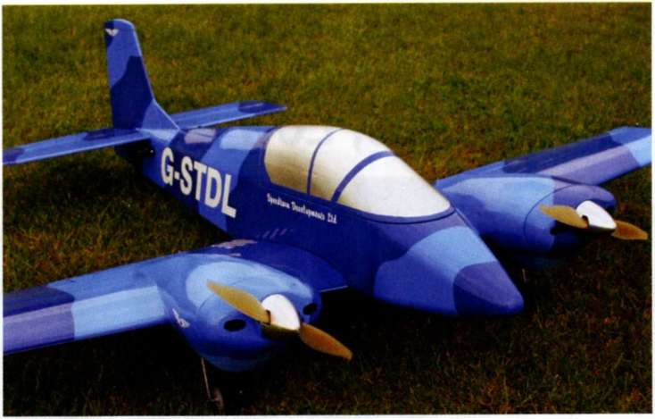

Those little wheels look a bit lost in the damp undergrowth, however there's no problem with take-offs.

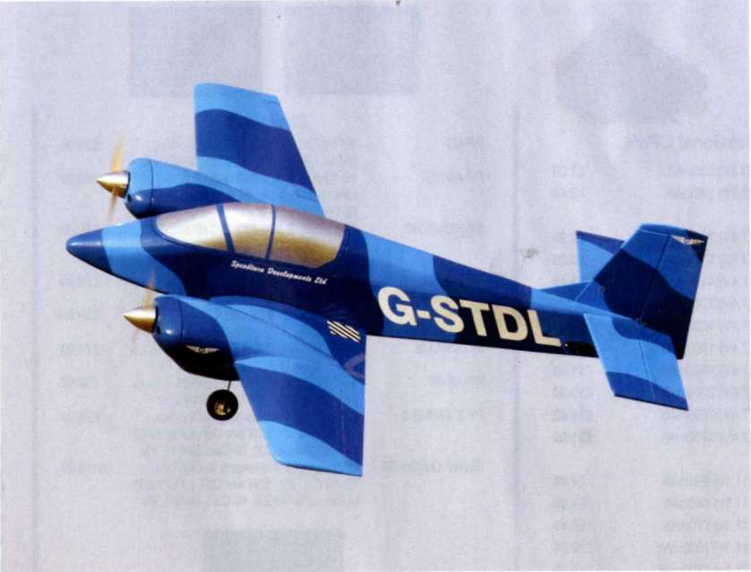

The ST2 is very happy in the air, with no vices to catch the unwary.

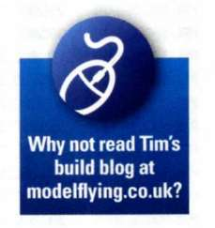

a scale competition or a pylon race, but as she happily races around the sky the Speedtwin is guaranteed to blow away the mental cobwebs of the weary and jaded pilot.

My ST2 already has quite a few flights under her belt and she's become one of my favourite everyday models. No, she's never going to win